Degold_Report_Megacities

In the year 1900, London was the most populous city on Earth. In 1950, New York and Tokyo both had a combined population of more than 20 million inhabitants. Since 2000 sixteen more cities have become megacities, cities with a population of more than 10 million people, and by 2025 there will be 36 megacities according to McKinsey Global Institute. The relevance of the topic is apparent and thus, this report aims to look at the major problems these cities face and how governments already cope with them today.

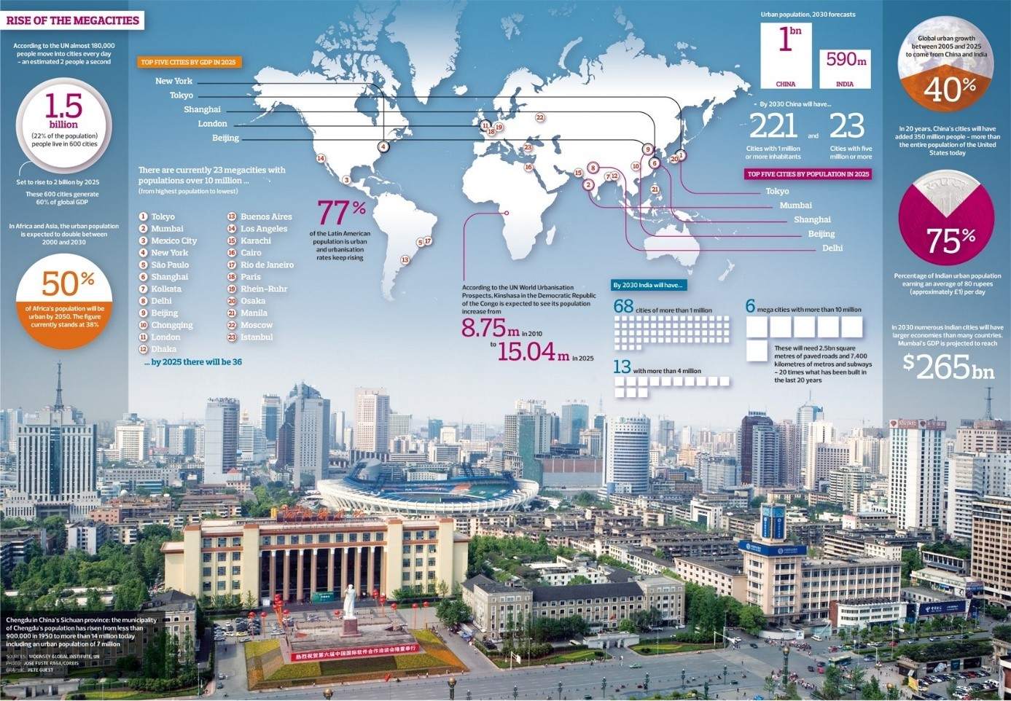

THE ORIGIN OF MEGACITIES:

One of the major reasons for the growth of cities is rural depopulation. People are moving to the cities because they see better opportunities for jobs and education. Because a lot of those immigrants are young people, the growth of those cities is significantly higher than in the surrounding areas.   
If one takes into account these factors, it is obvious that urban growth correlates with the degree of industrialization of a country. This fact is especially noticeable in developing countries, where most megacities are located. It is also reflected in a study by the UN, which prognosticates major urban growth in the countries of Africa and South Asia.

PROBLEMS OF MEGACITIES:

Megacities will be facing numerous problems, from socioeconomic to environmental ones. With relatively little living space available and many rural immigrants moving into urban neighbourhoods, many of the wealthier residents move to the outskirts. Thus, the poor residents and immigrants will inhabit city centers or slums around or within the city. Due to this huge inequality, there is also a relatively high level of crime in megacities, which, in combination with insufficient infrastructure and lack of investment, means that many parts of the city are left to themselves.  
Another big problem of megacities is environmental pollution. Many cities struggle with waste disposal, sewage discharge and air and groundwater pollution caused by for example e-waste recycling.

Possible solutions:

One megacity which has shown remarkable progress in the last years is Chengdu, the capital of the Chinese province Sichuan. Its government has helped developing the city’s surroundings effectively. The goal was to make it less attractive for people to move into the city. That was done by changing the nationwide household registration system, called Hukou. This system formerly made it impossible for rural migrants to register as citizens of the city and thus they were not able to benefit from the city’s welfare services. Now women over 55 and men over 60 that live outside of the city can claim pension if they paid premiums for at least 15 years. Also, the government of Chengdu has built a lot of new schools in the villages surrounding it to give pupils the chance of a higher education.  
With all those measures, the government has managed to reduce immigration.

CONCLUSION:

Nearly 55% of the world’s population live in cities. This figure is said to rise to 68% in the next decades according to the UN. Since many megacities are located in countries where there are political and economic tensions, finding solutions to all these problems will be challenging, but there are models of how cities should develop in order to guarantee a high standard of living.

­­­­­­­­Sources:

<https://www.theguardian.com/society/2012/jan/21/rise-megacity-live>